Automated User Provisioning/De-provisioning Integration Guide
Version 1.2

Document Information
Document Title: | Automated User Provisioning/De-provisioning Integration Guide
Document Owner: | Deborah Hornbeck
Program Manager: | Deborah Hornbeck
Telephone No: | 302-683-5154
Additional Contacts: | Don Richmond, Bryan Henry, Dennis Tapel
Release Date: | August 2009
Version No: | 1.2

References
User Provisioning Strategic Plan v2.0
EERS Application Integration Guide

Version History
Version | Date | Author | Comment / Changes from Prior Version
V 0.1 | 02/18/2009 | Dennis Tapel | Initial version - DRAFT
V 0.2 | 02/26/2009 | Dennis Tapel | Updated document to include Provisioning
V 0.3 | 03/04/2009 | Dennis Tapel | Updated numbering of Sections
V 0.4 | 03/09/2009 | Dennis Tapel | Added definitions for provisioning/deprovisioning. Re-numbered Sections.
V0.5 | 03/13/2009 | Dennis Tapel | Modified text display of SharePoint Links  Updated MarketPlace and OneApproval links
V0.6 | 03/16/2009 | Dennis Tapel | Updated Architecture Diagram and several sections
V0.7 | 03/20/2009 | Deb Hornbeck / Howie Berzon | Rearranged sections and updated some text
V0.8 | 03/26/2009 | Dennis Tapel/Bryan Henry | Updated Glossary, Product Designer and One Approval links and EERS Bulk File on comparison table.  Added Appendix A – One Approval – Approval Models
V1.0 | 04/02/2009 | Dennis Tapel | Finalized for posting and distribution
V1.1 | 04/10/2009 | Dennis Tapel | Removed link for One Approval – Global Approval Standard
V1.2 | 08/17/2009 | Dennis Tapel | Updated Contacts

Notice of Proprietary Property
Copyright © 2009 Citi. All rights reserved. FOR INTERNAL USE ONLY
These materials are confidential and proprietary to Citi, and no part of these materials should be reproduced, published in any form by any means, electronic or mechanical including photocopy or any information storage or retrieval system nor should the materials be disclosed to third parties without the express written authorization of Citi.

Table of Contents
Document Information 2
References 2
Version History 2
1 Introduction 4
1.1 Objectives 4
1.2 Scope 4
1.3 Target Audience 4
1.4 Glossary 4
2 Provisioning and Deprovisioning Automation Options 5
3 Complete Provisioning and Deprovisioning 7
4 EERS Deprovisioning using SUN IDM 8
5 EERS Deprovisioning using Bulk File 9
6 Comparison Chart 10
Appendix A – One Approval – Approval Models 11

Introduction
In many areas today, a worker who needs access added to or removed from an application or system follows the local Information Security Administration (ISA) process, which can vary greatly from other ISA processes. Once the request is approved, an ISA will then manually create (provision) or delete (deprovision) the access.
Automating the provisioning and/or deprovisioning processes can enhance the effectiveness and efficiency of security administration by ensuring that workers have the appropriate entitlements to perform job responsibilities with minimal administrative effort.

Objectives
The primary objective of this document is to provide both an overview of and detail regarding the provisioning and deprovisioning automation options available. Implementation of these solutions will:
- Streamline the access request process through standardized and automated workflow systems.
- Standardize the provisioning and deprovisioning processes and tools to simplify maintenance and administration of user entitlements.
- Provide end-to-end processes and capabilities to achieve compliance with Citi’s internal Information Security policies by ensuring timely and reliable account management.

Scope
This document covers a high-level list of integration steps and some general guidelines on how to leverage the automated provisioning and deprovisioning solutions to improve productivity. It is primarily geared towards existing applications.

Target Audience
The target audiences of this document are application developers, technology owners, business owners and ISA managers.

Glossary
CMP Citi MarketPlace
EERS Enterprise Entitlement Review System
ESB Enterprise Service Bus
IAM Identity and Access Management
ISA Information Security Administration
NDM Connect:Direct
OA OneApproval
SUN IDM Sun Identity Manager
VSR Virtual Security Request

Provisioning and Deprovisioning Automation Options
There are currently three automation options that are available to improve Security Administration productivity and comply with regulatory requirements by removing entitlements in a timely manner: These options are depicted in Figure 1 below.
1 Complete Provisioning and Deprovisioning (includes Cit MarketPlace for self-service creation/removal requests and EERS for revocation and termination requests (Refer to Section 3))
2 EERS Deprovisioning using SUN IDM (Refer to Section 4)
3 EERS Deprovisioning using Bulk Feed (Refer to Section 5)

Following is a brief description of the components, which provide the provisioning and deprovisioning. Refer to the following document for more detail on the overall architecture: User Provisioning Strategic Plan v2.0.
- Request Management: This component provides a user-friendly tool to request the assignment, change or removal of entitlements. Citi Marketplace (CMP) is the Citi technology for this component. Additionally, for entitlement removal, or deprovisioning, managers (or their delegates) may use the Enterprise Entitlement Review System (EERS). EERS issues removal requests directly to the Request Management component for selected products.
- Product Management: Entitlement request processes are centralized and standardized through the use of a Product Catalog concept. Using this component, entitlements available to be provisioned through the Request Manager (CMP) will appear in the catalog to the users who need to request them.
- Approval Management: Entitlement requests usually require approval by one or more approvers before entitlements are granted to the requester. The Citi component for this is OneApproval.
- Fulfillment Management: When all required approvals are gathered, fulfillment of the request is provided by an automated provisioning engine (automated fulfillment) or is manually fulfilled by an Information Security Administrator. The primary Citi tool for automated provisioning is Sun Identity Manager (Sun IDM).

Figure 1: Automation Architecture
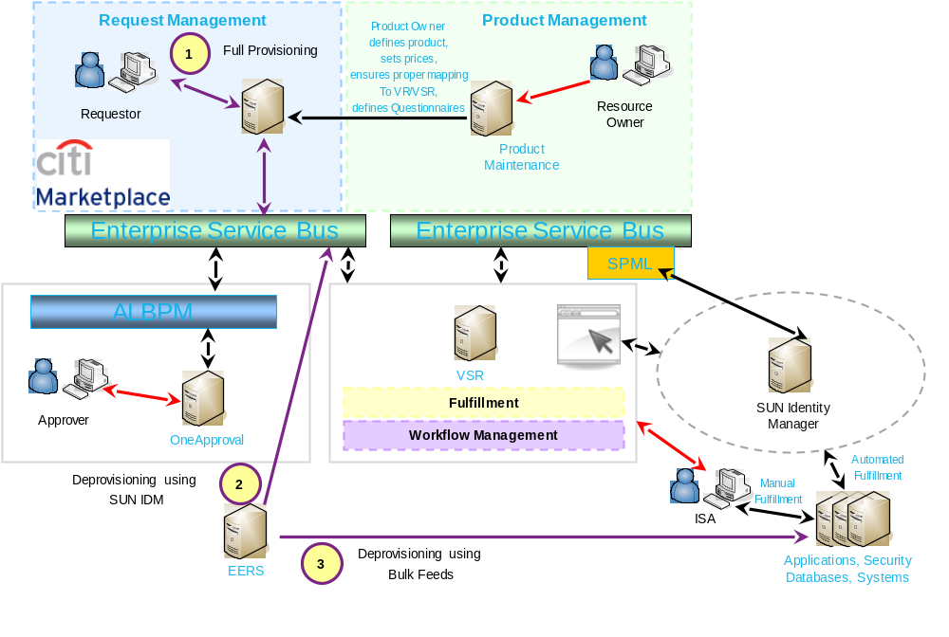

Complete Provisioning and Deprovisioning
The Complete Provisioning and Deprovisioning solution enables the creation and removal of user entitlements in the target application or system without human intervention, once the request is approved. The solution includes the following components:
- End-users request creation/removal of access via Citi MarketPlace
- Approval workflow processed through OneApproval system
- EERS revocation and termination requests also pass through (Refer to Section 4)
- Straight-through provisioning/deprovisioning using SUN IDM and VSR for tracking

Benefits:
- Uses standardized enterprise front end solutions (CMP or EERS)
  - Easy to request
- Requests initiated via CMP go through pre-arranged approval process (OneApproval)
  - Easy to approve
- Requests are automatically processed through Sun IDM
  - Rapid execution – seconds or minutes vs. days
- Reduced error rates
- Fully integrated and standardized enterprise solution

Requirements:
- Product setup (CMP/VSR)
- Approval process setup (One Approval)
- Stored procedure or Web Service creation (Local Application)
- Testing in UAT

Contact:
- Don Richmond - don.richmond@citi.com

Reference Documents:
- User Provisioning Strategic Plan v2.0
- MarketPlace Overview
- MarketPlace Product Designer Guide
- The following SUN IDM reference documents may be found at the following location:
  - CATE Solutions Development SUN Implementation Guidelines
  - SUN IDM Stored Procedures Interface Specifications
  - SUN Identity Manager Web Service Interface Specifications
- The following One Approval reference documents may be found at the following location:
  - Approval Models – additional information can be found on Appendix A
  - One Approval User Guide
- VSR Information Page – Documents, FAQ and Contacts

EERS Deprovisioning using SUN IDM
Every day, thousands of applications feed user entitlement information to the Enterprise Entitlement Review System (EERS). Managers are reviewing those worker entitlements and, where appropriate, requesting entitlement revocations or deletions. Additionally, when a worker is terminated, EERS recognizes that they’ve left the company and generates deletion requests.
User deletion, revocation, and/or termination requests from EERS can be processed automatically by utilizing Sun IDM. This entails a simple modification to an application using Stored Procedures or Web Services.
Benefits:
- All requests generated in EERS are automatically processed through Sun IDM
  - Productivity and compliance with CISS regarding ISA turnaround time
  - Less volume of requests require ISA involvement
- If any EERS requests are not processed automatically, they will be sent to the ISA team
- ISA groups that work from VSR/CMP request and also from EERS email request can transition to a single process using VSR
- Can be a leverage to ultimately automate user provisioning

Requirements:
- Function Codes sent to EERS need to be interpreted properly by Sun IDM
- Stored Procedure or Web Service setup (Local Application)
- Testing in UAT

Contact:
- Don Richmond - don.richmond@citi.com

Reference Documents:
- MarketPlace Overview
- MarketPlace Product Designer Guide
- The following SUN IDM reference documents may be found at the following location:
  - CATE Solutions Development SUN Implementation Guidelines
  - SUN IDM Stored Procedures Interface Specifications
  - SUN Identity Manager Web Service Interface Specifications
- VSR Information Page – Documents, FAQ and Contacts

EERS Deprovisioning using Bulk File
Every day, thousands of applications feed user entitlement information to the Enterprise Entitlement Review System (EERS). Managers are reviewing those worker entitlements and, where appropriate, requesting entitlement revocations or deletions. Additionally, when a worker is terminated, EERS recognizes that they’ve left the company and generates deletion requests.
EERS can automatically deliver user entitlement revocation and/or termination requests via a text formatted flat file to be used by the requesting Application Team and ISA to automate the revocation process for new and existing applications. New requests will be transmitted via NDM; past due (weekly) notifications will continue to be sent by email to the ISA group.
Benefits:
- Applications unable to interface with Sun IDM can automatically process termination/revocation feeds from EERS
- All requests generated in EERS are sent to the system to be automatically processed through localized procedures
  - Productivity and compliance with CISS regarding ISA turnaround time
  - Less volume of requests require ISA involvement
- If any EERS requests are not processed automatically, they will be sent to ISA in the weekly Wednesday cumulative report
- Note, since this is not integrated with Sun IDM, this solution does not enable the automation of new provisioning requests

Requirements:
- Functions sent to EERS need to be interpreted properly by localized process
- Stored procedure setup (Local Application)
- NDM Connection
- Testing in UAT

Reference Document:
- Automated Notifications - EERS Bulk File Format

Contacts:
- Initial Contact: Bryan Henry – bryan.t.henry@citi.com
- EERS Application Support – EERSApplicationSupport2@imcnam.ssmb.com

Comparison Chart
To assist in selecting the appropriate solution, the below chart summarizes several of the aspects of each.
 | Provisioning / Deprovisioning Automation Options
 | Complete | SUN IDM | EERS Bulk File
Functions
Automated Provisioning – Self-service via CMP | YES | NO | NO
Automated Deprovisioning – Self-service via CMP | YES | NO | NO
Automated Deprovisioning – via EERS | YES* | YES* | YES*
Requirements for Implementation
CMP Product Setup | YES | YES | NO
EERS Function Code mapping to CMP Product | YES | YES | NO
Approval Process Setup (OneApproval) | YES | NO | NO
Stored Procedure Setup (Application) | YES | YES | YES
Web Services Setup (or Stored Procedure) | YES | YES | NO
Testing in UAT | YES | YES | YES
NDM Setup (Application) | NO | NO | YES
Exception Handling | VSR | VSR | Local App**
Benefits
Increased ISA Productivity | YES | YES | YES
CISS compliance with ISA turn around time | YES | YES | YES
Front end request availability | YES (CMP) | YES (EERS) | YES (EERS)
ISA notification for de-provisioning failure | YES (VSR/EERS) | YES (VSR/EERS) | YES (EERS)

*Stored procedure, web service, or code/scripting required at local application level.
**Local App means that some coding or scripting is required by the Application Manager to deploy this solution.

Appendix A – One Approval – Approval Models
The following generic approval workflows are currently available in One Approval (OA):
- Business Manager Approver
- Financial Approval
- Listed Approvers – All
- Listed Approvers – Any
- VT Group – Asset Custodian
- VT Group - Reviewer
- External Approval Model
- Business Unit Approvers
- EERS Approval Model
- No Approval Required
- One Reset

- Business Manager Approval
OA routes the request to the requestor’s manager, based on the GDW hierarchy. The manager can approve, forward or reject as required.

- Financial Approval
This model uses p2p as the golden source of approvers & approval limits. OA checks if the approver can approve based on the commodity, currency & amount provided by Marketplace.
- If the item is within the manager’s approval limits, they can approve, forward or reject.
- If the item is outside the approval limits, they can forward or reject only.
If a manager chooses to forward, they can only forward to someone who is entitled to approve.

3. & 4. “Listed Approvers – All” & “Listed Approvers – Any”
These models expect to receive a list of approvers from the originating system.
- “Listed Approvers – All” requires ALL in the list to approve before the request is deemed “approved”.
- “Listed Approvers – Any” requires at least one person in the list to approve before the request is deemed “approved”.

5. VT Group – Asset Custodian
This model allows the product manager to route a request to a group (one or more individuals), who can edit the costs on the request before forwarding to the Financial Approver. This process is used extensively in NA, where product costs are not known at the time of ordering.

6. VT Group – Reviewer Not currently available for general use.
Dept (defined in GDW) can add an extra approver to a Marketplace product. The approver is appended to the existing approval process. Only requests raised by that dept get routed to this reviewer.

7. External Approval Model
The External Model allows OA to extract approval flow information from an external system. This is used for complex approval flows, where the flow may change on a request by request basis.
CSI, ADMGT & VSR all use the External Model in production today.

8. Business Unit Approvers
This model was added to meet the approval need for CDTS requests. BUMs are defined in VSR – OA reaches out to VSR to identify who needs to approve, & then routes the request accordingly.

9. EERS Approval Model
Model used exclusively by EERS for automated deprovisioning.

10. No Approval Required
Some products do not require active approval. This model auto-routes the requests to the relevant provisioning system.

11. One Reset
New model created for the One Reset system. The approval logic is straight forward. If the “Request By” user & the “Requested For” user are the same, the request gets auto-approved. If not, the request is routed to the Business Manager of the “Requested For” user, who can approve or reject as appropriate.

